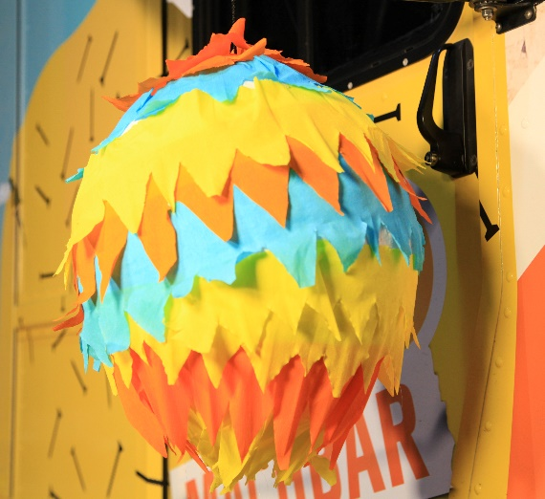
How to make a piñata

The piñata is an old tradition in Mexico.
It comes from the time of the Mayas and Aztecs.
Today, it is a party game in South America at
Christmas and on birthdays.
Children are blindfolded and hit the piñata
with a stick. The piñata is filled with sweets.

To make a piñata you need: glue, a brush, a balloon, a piece of string, sweets,
a stick or a pencil, scissors, some paper and some colourful crepe paper.

1. Prepare the body:  Blow up the balloon.  Tear the paper into pieces.  Mix the glue.  Glue the paper on the balloon. | 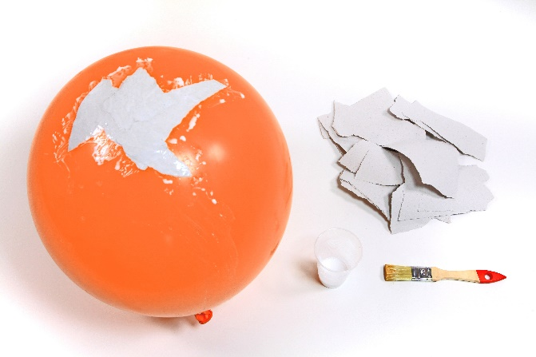
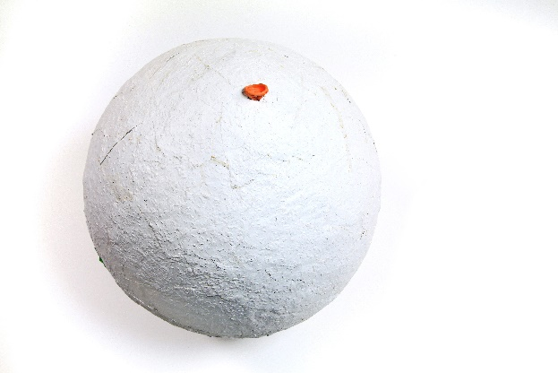 | 2. Cover the balloon with paper:  Glue the paper all over the balloon.  Leave one small hole at the top.  Let it dry for one day.
3. Remove the balloon:  Cut a slit in the balloon.  Let the air out.  Remove the balloon. | 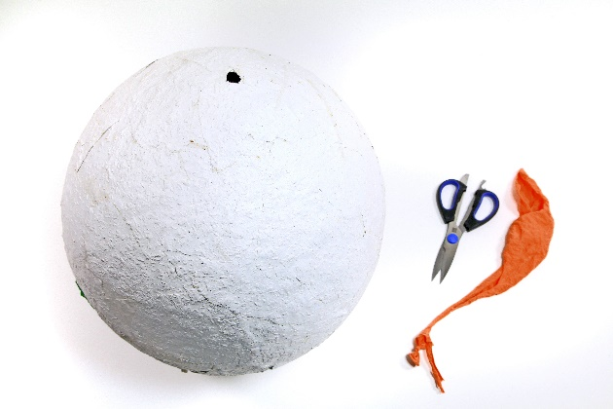
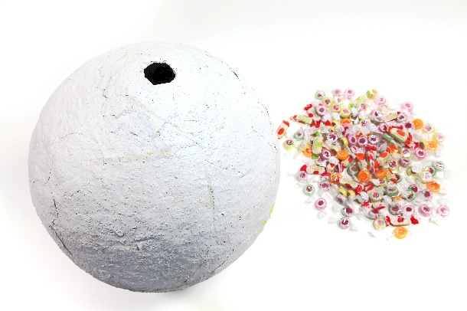 | 4. Fill the balloon:  Cut the hole a little bit bigger.  Fill the body with sweets.  Don’t make it too heavy.
5. Prepare the crepe paper:  Cut a pattern into the crepe paper.  Use the colours you like. | 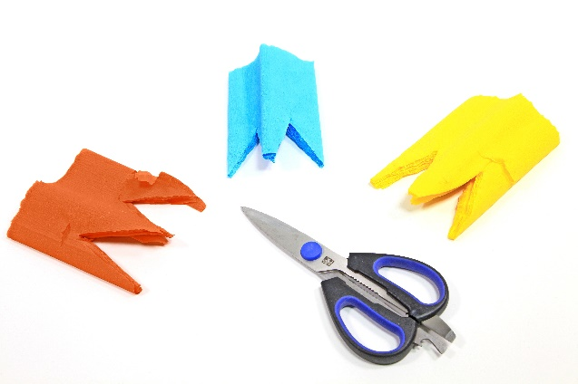
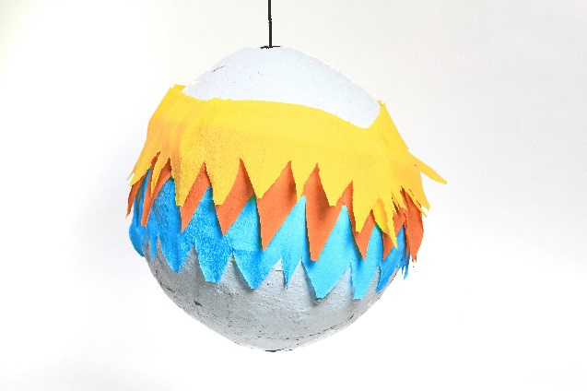 | 7. Decorate the piñata:  Stick the crepe paper to the body.
8. Hang up the piñata:  Wrap the string around a stick or pencil.  Push the stick or pencil through the hole.  Hang it up and start playing! | 