Black Friday

1) Receptive task: Reading an obituary

a) Pre-reading task: Discuss with a partner.

- What comes to your mind when you hear the words Black Friday?
- Do you think it’s a positive or negative event? Why?

b) Read the obituary.
Info box: What is an obituary?
An obituary is a short text written to announce and reflect on someone’s death.
It often appears in newspapers or online and combines facts about the person’s life with personal or emotional commentary.

Obituary

Here lies Black Friday: 1950s–2025(?)

It is with mixed feelings (but mostly relief) that we announce the passing of Black Friday, the chaotic consumer holiday that once ruled the fourth Friday of November, the day after Thanksgiving. Born in Philadelphia, Black Friday was first named by police officers who witnessed streets packed, traffic at a nightmare level, and shoplifters on the prowl as shoppers scrambled for Christmas presents. It the early days of Black Friday glory, families went to bed early, only to wake at 4 AM, line up for blocks, and fight their way into stores for a TV discounted 80% or a coffee machine slashed 70%. Yes, Black Friday fights were a thing, and yes, people actually survived them … mostly.
In all fairness, Black Friday did become a cultural phenomenon. Now, however, retailers extend deals across weeks, sometimes starting as early as Halloween, with Amazon famously opening the floodgates on Thanksgiving itself. By 2025, only die-hard bargain hunters will chase the actual Black Friday sales, like at the LEGO Store, while everyone else comfortably shops online in their pyjamas, sipping coffee rather than fighting over giant teddy bears at TESCO.
Black Friday’s life was full of irony: stores would put down prices temporarily to encourage shoppers to buy more, while inflating some prices earlier in the year so discounts seemed bigger than they were. Businesses went from red to black, and shoppers went from excitement to mild panic – all in the name of consumer capitalism. In Wales, it is called Dydd Gwener y Gwario Gwirion, or “Silly Spending Friday,” which might have been the most accurate title of all.
Though Black Friday was known for its frivolous impulse buys, complete disregard for the environment (think tons of packaging), and early-morning chaos, it also sparked resistance. Consumers began standing up against corporate greed, joining boycotts like Buy Nothing Day, or finding more fulfilling ways to spend the Friday after Thanksgiving.
Black Friday, you will be remembered for your crazed shoppers, 10-block lines, and headline-grabbing fights, but also for showing us why shopping isn’t everything. May your bargains rest in peace – and may our wallets finally recover. And, Black Friday, don’t you dare step out of your grave on November 29, 2025.
c) Post-reading task 1: Standardised test format (multiple choice)

Choose the best answer.

- The phrase Black Friday originally referred to
a) the moment retailers moved from financial loss to profit.
b) a day of massive discounts and shopping celebrations.
c) the chaos, traffic jams, and shoplifting after Thanksgiving in Philadelphia.
d) Silly Spending Friday.

- What does the text suggest about people’s early Black Friday traditions?
a) They saw it as a calm way to prepare for Christmas.
b) It was treated almost like a family ritual, despite the madness.
c) Most people ignored it until the 1980s.
d) It was limited to police officers and retailers.

- The phrase “went from red to black” refers to
a) a change in store decorations.
b) how businesses shifted from losing money to making profit.
c) how consumers started to do their shopping differently.
d) the environmental impact of the shopping season.

- According to the obituary, Black Friday’s decline is mainly due to
a) new laws restricting consumer spending.
b) public safety concerns about in-store fights.
c) the rise of online shopping and extended sales periods.
d) the disappearance of Thanksgiving traditions.

- The tone of the obituary can best be described as
a) serious and scientific.
b) nostalgic but ironic.
c) bitter and angry.
d) neutral and informative.

- When the text mentions Wales’ name for Black Friday, “Silly Spending Friday”, this mainly serves to
a) show how seriously other countries take Black Friday.
b) criticise Americans for overspending.
c) highlight the absurdity of the shopping frenzy in a humorous way.
d) suggest that Wales invented the name “Black Friday.”

- What underlying message does the text express about consumer culture?
a) It creates more happiness and social connection.
b) It encourages environmental awareness.
c) It often manipulates people and promotes unnecessary buying.
d) It is an important tradition that keeps the economy alive.
d) Post-reading task 2: A crossword puzzle

Complete the crossword puzzle.

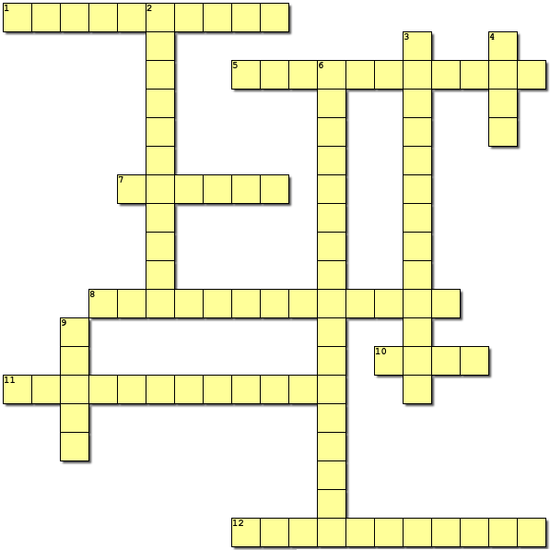

- When stores go from losing money to making a profit.
- The day after Thanksgiving when stores have big discounts.
- The period including Thanksgiving, Black Friday, and Christmas.
- A place where many Black Friday shoppers go in person.
- The online version of Black Friday deals.
- Shoppers waiting before stores open to get the best deals.
- The excitement and rush surrounding Black Friday shopping.
- A movement encouraging people not to buy anything for a day.
- Items offered at lower prices than usual.
- “Fear of missing out”, which can drive shoppers to buy quickly.
- U.S. holiday celebrated on the fourth Thursday of November.
- A culture focused on buying goods and services.

2) Productive task: Speaking

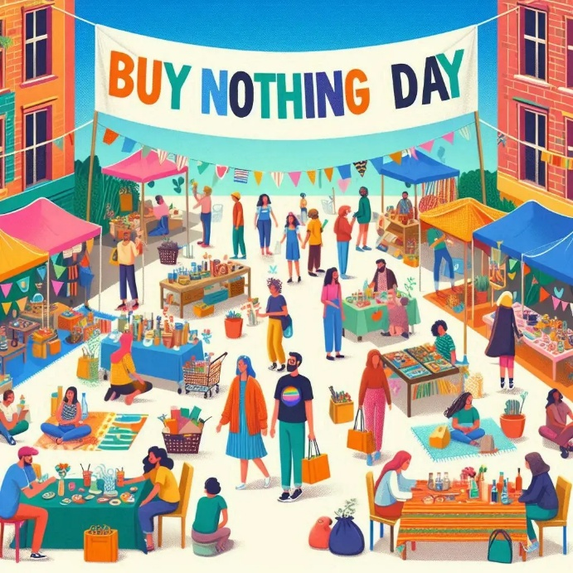
(Created with Bing Image Creator)
a) Individual long turn: Consumer behaviour

Give a five-minute talk on the topic of consumer behaviour in which you
• compare and contrast the pictures,
• reflect on what influences young people’s consumer behaviour,
• explain what the advantages and disadvantages of living in a consumer society are.

b) Paired activity: Teenage life in a consumer society

Your school is organising a project day and has invited you and your partner to give a talk about life as a teenager in a consumer society like Austria. You have ten minutes to discuss the following aspects and come to a clear decision as to what to include in your talk:
• choices of products
• fear of missing out on deals
• shopping trends
• moral and environmental concerns
• happiness
3) Creative task: Black Friday FOOH

a) Go online and search for the biggest fooh ad library (fooh.com). Then use the library to find the fooh “Roborock Vacuum Under Gold Vending Machine” (https://fooh.com/library/525-roborock-robot-vacuum-gold-bars-fooh-ad/). It is considered one of this season’s best Black Friday FOOHs.

b) Watch the FOOH, then correct the ten factual mistakes in this summary of the ad.

This FOOH campaign opens with a woman lying on the train platform floor, searching under a bench. This scene cleverly emphasizes the product’s efficiency in unexpected situations, as a robotic mop approaches, its headlight glowing. The vacuum glides quietly across the floor, picking up dust and dirt, and smoothly slides under the bench. From behind it, the robot pushes out three gold bars, leaving a spotless trail in its wake. The bench is adorned with a Cyber Monday ad for the vacuum, showcasing the product. Suddenly, the bench inflates and opens, releasing gold bars that scatter across the floor. Bold blue text then appears: “Up to 250€ OFF.” The campaign encourages everyone to treat themselves to this handy helper for Black Friday. Combining innovative storytelling with captivating product integration, the computer-generated graphics are designed to grab attention throughout the promotion. The ad is great because it showcases two qualities of the vacuum, efficiency and reach, by embedding these inside a Black Friday metaphor (finding hidden value).

Info box: What is a “FOOH”?

FOOH stands for fake out of home (or faux out of home) advertising.
It’s a short, digitally created video that looks like a real advert.
These clips are designed to look realistic but are made with AI or 3D animation, then shared on social media to grab attention and go viral.
They’re called “fake” because the ad doesn’t exist in the real world but is only spread online.

c) Design your own FOOH ad for this year’s Black Friday.

- Choose a product. It can be real or imagined.
- Plan the scenario. Think about where this situation would take place in the real world.
- Add key messaging. Think about slogans, prices, or promotional offers.
- Optional: create the visuals. Use drawing, collage, or simple digital tools like Canva, Photoshop, or PowerPoint.
Info box: What is an elevator pitch?

An elevator pitch is a quick, 30–60 second explanation of an idea or product. It’s called an elevator pitch because it should be short enough to deliver during a brief elevator ride. It should be concise, engaging, and memorable.
- Optional: add an animation or digital effect. Use free tools like Canva, Crello, Animaker, Powtoon, or Kapwing.

d) Present your Black Friday FOOH ideas to your classmates in the form of an elevator pitch.

Black Friday: Key

1) Receptive task: Reading an obituary

c) Post-reading task 1: Standardised test format (multiple choice)

1c) the chaos, traffic jams, and shoplifting after Thanksgiving in Philadelphia.
→ The text explains that Black Friday was first used by police to describe the post-Thanksgiving disorder in Philadelphia.

2b) It was treated almost like a family ritual, despite the madness.
→ Families “went to bed early, woke at 4 AM, lined up for blocks, and fought their way into stores” – this shows excitement mixed with chaos.

3b) how businesses shifted from losing money to making profit.
→ The idiom “from red to black” means moving from debt (red numbers) to profit (black numbers).

4c) the rise of online shopping and extended sales periods.
→ The obituary states that retailers now extend deals across weeks, and most shoppers buy online instead of camping outside stores.

5b) nostalgic but ironic.
→ The text imitates an obituary style — humorous, slightly sentimental, but clearly mocking consumer culture.

6c) highlight the absurdity of the shopping frenzy in a humorous way.
→ Mentioning “Silly Spending Friday” underlines the irony and exaggeration of consumer behaviour.

7c) It often manipulates people and promotes unnecessary buying.
→ The final paragraphs criticise consumer capitalism, fake discounts, and environmental harm while praising Buy Nothing Day.
d) Post-reading task 2: A crossword puzzle

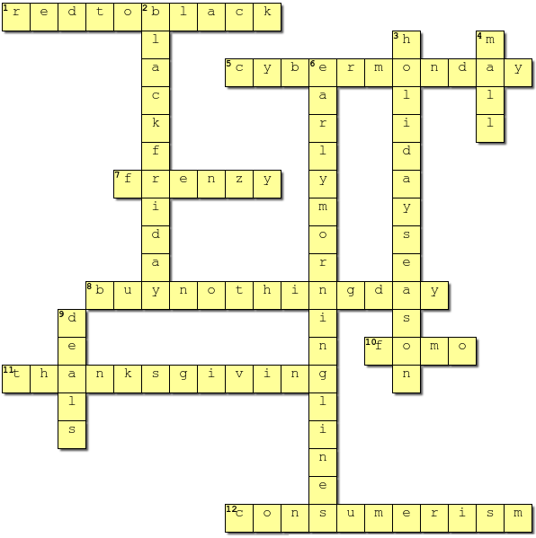

- When stores go from losing money to making a profit. (3 words: red to black)
- The day after Thanksgiving when stores have big discounts. (2 words: Black Friday)
- The period including Thanksgiving, Black Friday, and Christmas. (2 words: holiday season)
- A place where many Black Friday shoppers go in person. (mall)
- The online version of Black Friday deals. (2 words: Cyber Monday)
- Shoppers waiting before stores open to get the best deals. (3 words: early morning lines)
- The excitement and rush surrounding Black Friday shopping. (frenzy)
- A movement encouraging people not to buy anything for a day. (3 words: Buy Nothing Day)
- Items offered at lower prices than usual. (Deals)
- “Fear of missing out”, which can drive shoppers to buy quickly. (FOMO)
- U.S. holiday celebrated on the fourth Thursday of November. (Thanksgiving)
- A culture focused on buying goods and services. (consumerism)
3) Creative task: Black Friday FOOH

b) Watch the FOOH, then correct the ten factual mistakes in this summary of the ad.

This FOOH campaign opens with a woman lying on the train subway platform floor, searching under a bench vending machine. This scene cleverly emphasizes the product’s efficiency in unexpected situations, as a robotic mop vacuum cleaner approaches, its headlight glowing. The vacuum glides quietly across the floor, picking up dust and dirt, and smoothly slides under the bench vending machine. From behind it, the robot pushes out three two gold bars, leaving a spotless trail in its wake. The bench vending machine is adorned with a Cyber Monday Black Friday ad for the vacuum, showcasing the product. Suddenly, the bench vending machine inflates and opens, releasing gold bars that scatter across the floor. Bold blue red text then appears: “Up to 250€ 400€ OFF.” The campaign encourages everyone to treat themselves to this handy helper for Black Friday. Combining innovative storytelling with captivating product integration, the computer-generated graphics are designed to grab attention throughout the promotion. The ad is great because it showcases two qualities of the vacuum, efficiency and reach, by embedding these inside a Black Friday metaphor (finding hidden value).

